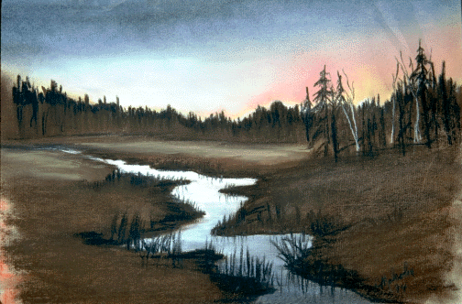
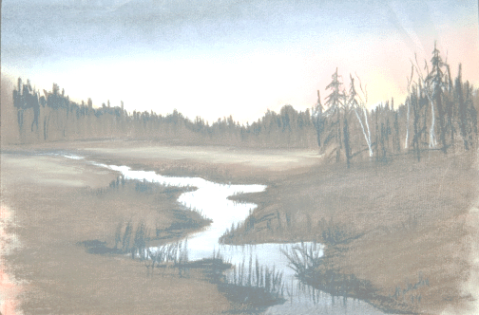
Today, your search can be over.

The Bible Says:

Jesus saith unto him, I am the way, the truth, and the life: no man cometh unto the Father, but by me. (John 14:6)

Come unto me, all ye that labour and are heavy laden, and I will give you rest. (Mark 11:28)

For whosoever shall call upon the name of the Lord shall be saved. (Romans 10:13)

You don’t have to go through life only to find vanity, when God has offered to you life, and more abundantly.

If you’re ready to end your search, pray:
God, be merciful to me a sinner. Forgive me of all my sins. Wash me in the blood you shed on the Cross of Calvary. Come into my heart to be my Savior. I make you the Lord of my life. Thank you, Jesus, for saving my soul!

Deliverance Center
1008 Congress Street
Portland, Maine
(207) 774-8192

Sunday School..........................................10:00 a.m.
Sunday Morning Service..........................11:00 a.m.
Sunday Evening Service……………...…6:30 p.m.
Wednesday Night Bible Study…………..7:00 p.m.
Friday Night Youth Service…………..…7:00 pm.

VISIT US ANYTIME!!!


Today, your search can be over.

The Bible Says:

Jesus saith unto him, I am the way, the truth, and the life: no man cometh unto the Father, but by me. (John 14:6)

Come unto me, all ye that labour and are heavy laden, and I will give you rest. (Mark 11:28)

For whosoever shall call upon the name of the Lord shall be saved. (Romans 10:13)

You don’t have to go through life only to find vanity, when God has offered to you life, and more abundantly.

If you’re ready to end your search, pray:
God, be merciful to me a sinner. Forgive me of all my sins. Wash me in the blood you shed on the Cross of Calvary. Come into my heart to be my Savior. I make you the Lord of my life. Thank you, Jesus, for saving my soul!

Deliverance Center
1008 Congress Street
Portland, Maine
(207) 774-8192

Sunday School..........................................10:00 a.m.
Sunday Morning Service..........................11:00 a.m.
Sunday Evening Service……………...…6:30 p.m.
Wednesday Night Bible Study…………..7:00 p.m.
Friday Night Youth Service…………..…7:00 pm.

VISIT US ANYTIME!!!

Have You Found

Outside Tract
A

What Your Searching For ?

Have You Found

Outside Tract
B

What Your Searching For ?

